CS 340 README Final Project

About the Project/Project Title

Austin Animal Center CRUD Python Module and Dashboard:
This project is a full-stack application that connects a MongoDB database containing Austin Animal Center data into an interactive dashboard. The project uses an object-oriented AnimalShelter class that provides database functionality with Create, Read, Write, and Delete operations. The CRUD Python module allows the dashboard to retrieve and filter animal records directly from MongoDB. The dashboard was created using Dash and includes an interactive data table, rescue type filtering options, a breed distribution pie chart, and an interactive geolocation map. These features allow users to identify dogs that meet the preferred requirements for water rescue, mountain/wilderness rescue, and disaster/individual tracking.

Motivation

The purpose of this project is to separate database operations from other parts of the application. By placing the CRUD functionality for the MongoDB inside of a reusable Python class will allow other Python programs to import the module instead of rewriting database code each time. This design will also make it easier to connect the database to a user interface in later portions of the project.

Getting Started

The Austin Animal Center dataset was imported into MongoDB using the database name aac and the collection name animals. A MongoDB account named aacuser was created in the admin authentication database and given the readWrite role for the aac database.

The CRUD_Python_Module.py file contains the AnimalShelter class which creates a MongoDB connection when instantiated. The create() method validates that the input is a nonempty Python dictionary, inserts the document with insert_one(), and returns true if MongoDB acknowledges the insert. The read() method accepts a dictionary containing query criteria, uses MongoDB’s find() method, and converts the resulting cursor into a Python list. The update() method accepts a query and a dictionary of updated values, uses update_many() with the $set operator, and returns the number of documents that are modified. The delete() method accepts a query, uses delete_many() to remove any matching documents, and returns the number of documents that are deleted.

Installation

This project uses the following tools:

Python 3 is used to create the object-oriented CRUD module and testing script.

MongoDB is used as the document database that stores the Austin Animal Center records. MongoDB allows the documents to be stored as flexible document-based data.

PyMongo is the Python driver used to connect the Python module to MongoDB. It provides the MongoClient, insert_one(), find(), update_many(), and delete_many() functionality used by the CRUD module.

JupyterLab and Jupyter Notebook is used to execute and test the Python module interactively. This makes it easy to view the results of the Create, Read, Update, and Delete operations.

Codio provides the course development environment that contains MongoDB, JupyterLab, and the AAC dataset.

Usage

Code Example
The Python module can be imported into another Python project. This creates an instance of the AnimalShelter class and allows for the use of CRUD functions.
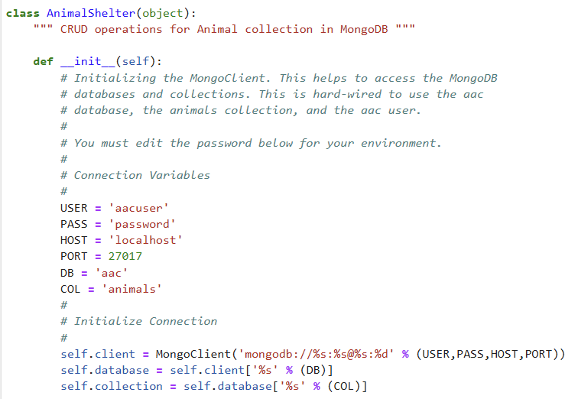

Tests

The module was tested using the ProjectOneTestScript.ipynb. The test notebook imported the AnimalShelter class, created an object, inserted a new test record, queried MongoDB for the newly created record, updated the created record, and deleted the same record.
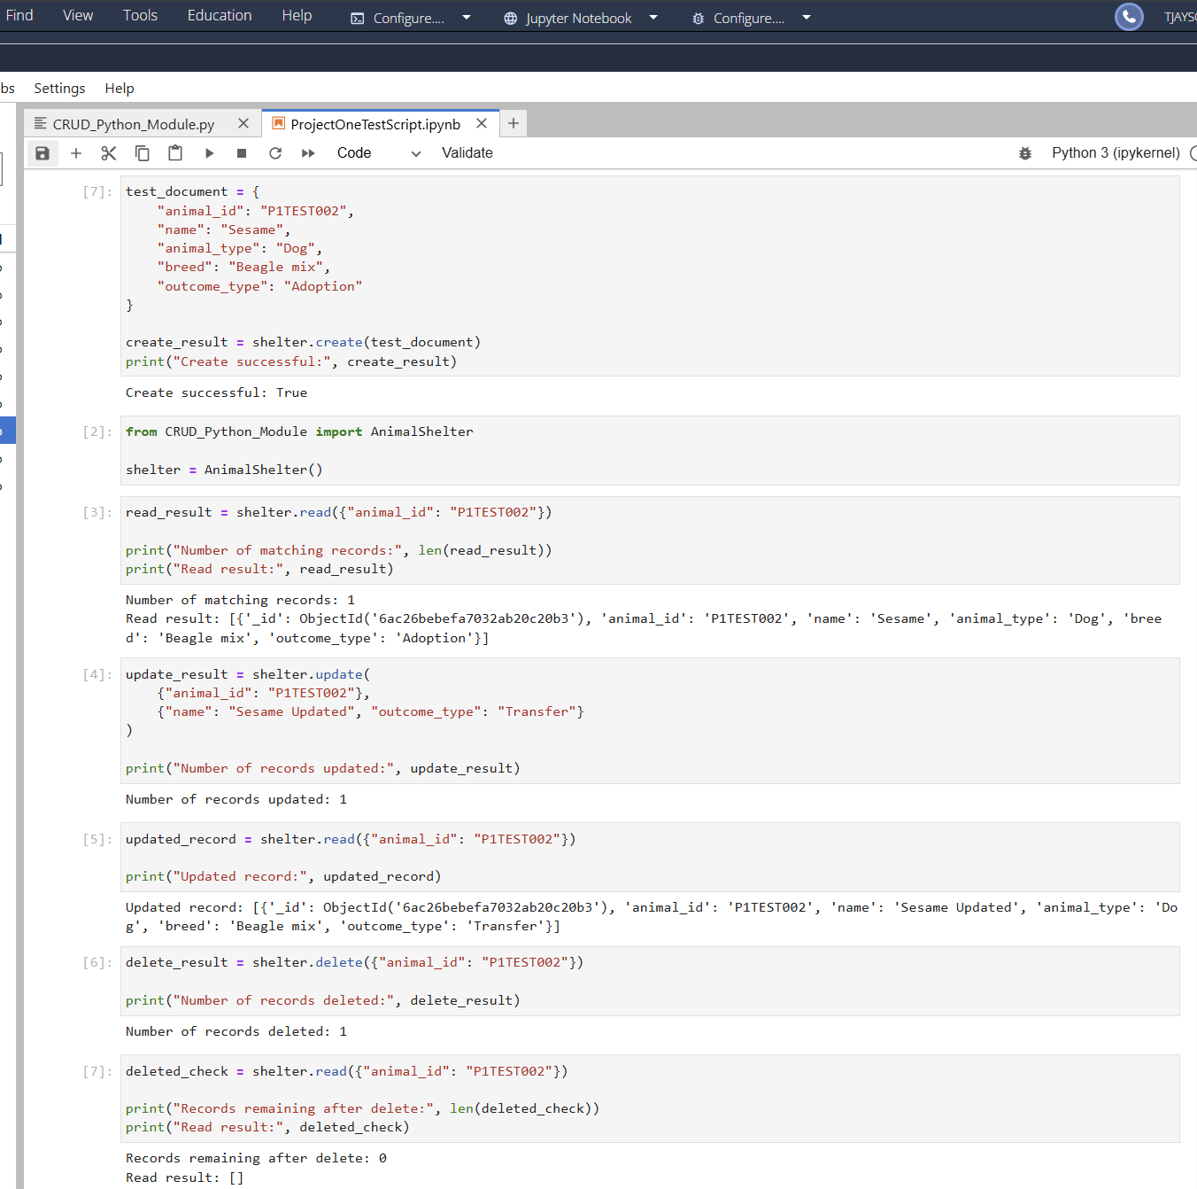

Screenshots
This is the code that allows for the user to create new records
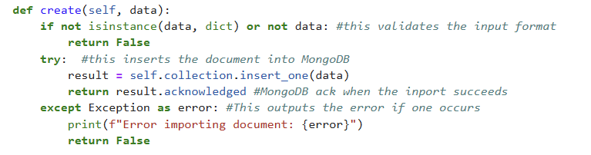

This is the code that allows the user to query the database for records that are already existing.
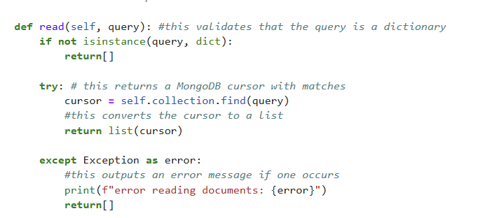

This is the code that allows the user to query the database for records and update the information saved
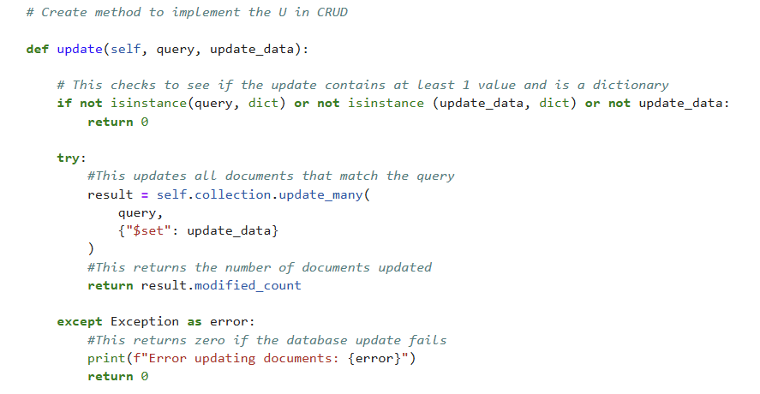

This is the code that allows the user to query the database and delete records
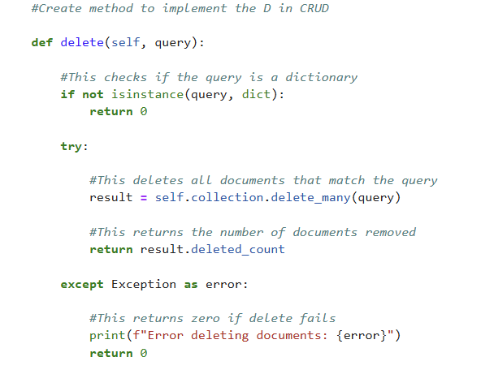

This is the MongoDB import screen shot
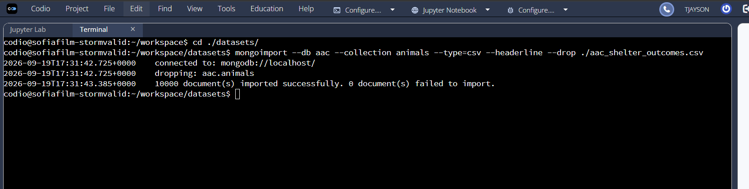

This is the account creation screenshot for the accusr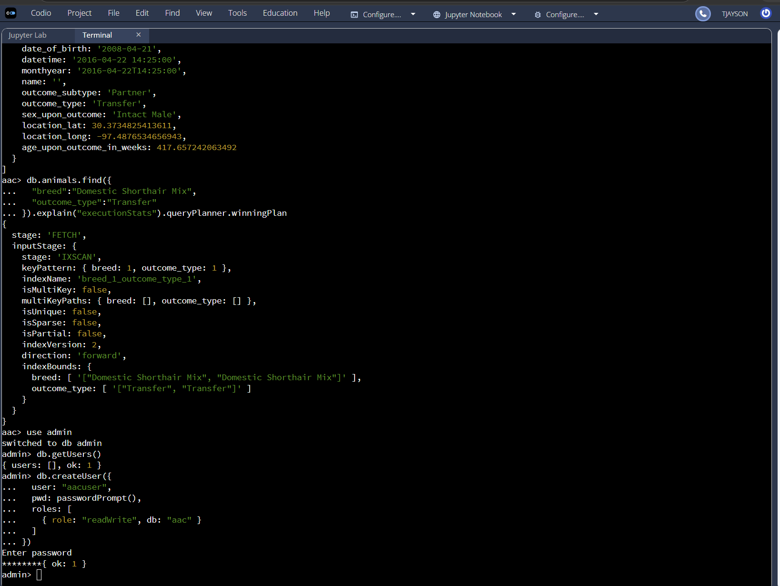
This is the account authentication screenshot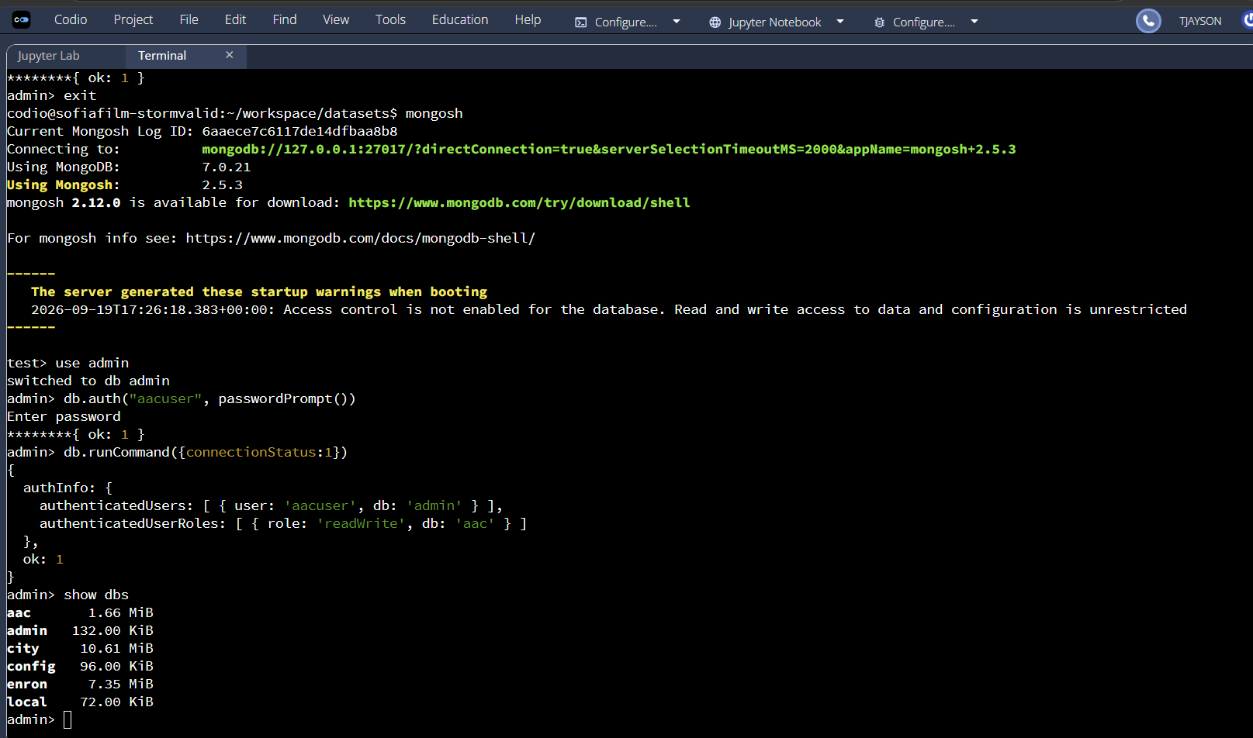

Contact
Your name: Tim Jayson

